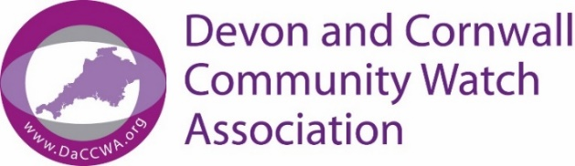

Guidance on who can support your application to become a Neighbourhood Watch Scheme Co-ordinator

Your application to become a Neighbourhood Watch Scheme Co-ordinator must be supported by someone who lives in your community and knows you personally.

Who can support your application?
They must:
- have known you for at least 2 years OR
- be able to identify you, for example they’re a friend, neighbour or colleague (not just someone who knows you professionally) AND
- be ‘a person of good standing in their community’ or work in (or be retired from) a recognised profession.

By signing your application form they are confirming that:
- you’re who you claim to be.
- as far as they know, all the information you’ve put on the form is true.

Who cannot support your application?
You cannot ask someone to support your application if you’re:
- related to them by birth or marriage.
- in a relationship with or live at the same address as them.

What they must do and can expect
They must add their name, signature and the date in Section 5 of your Application Form.

They may be contacted by DaCCWA for more information.

